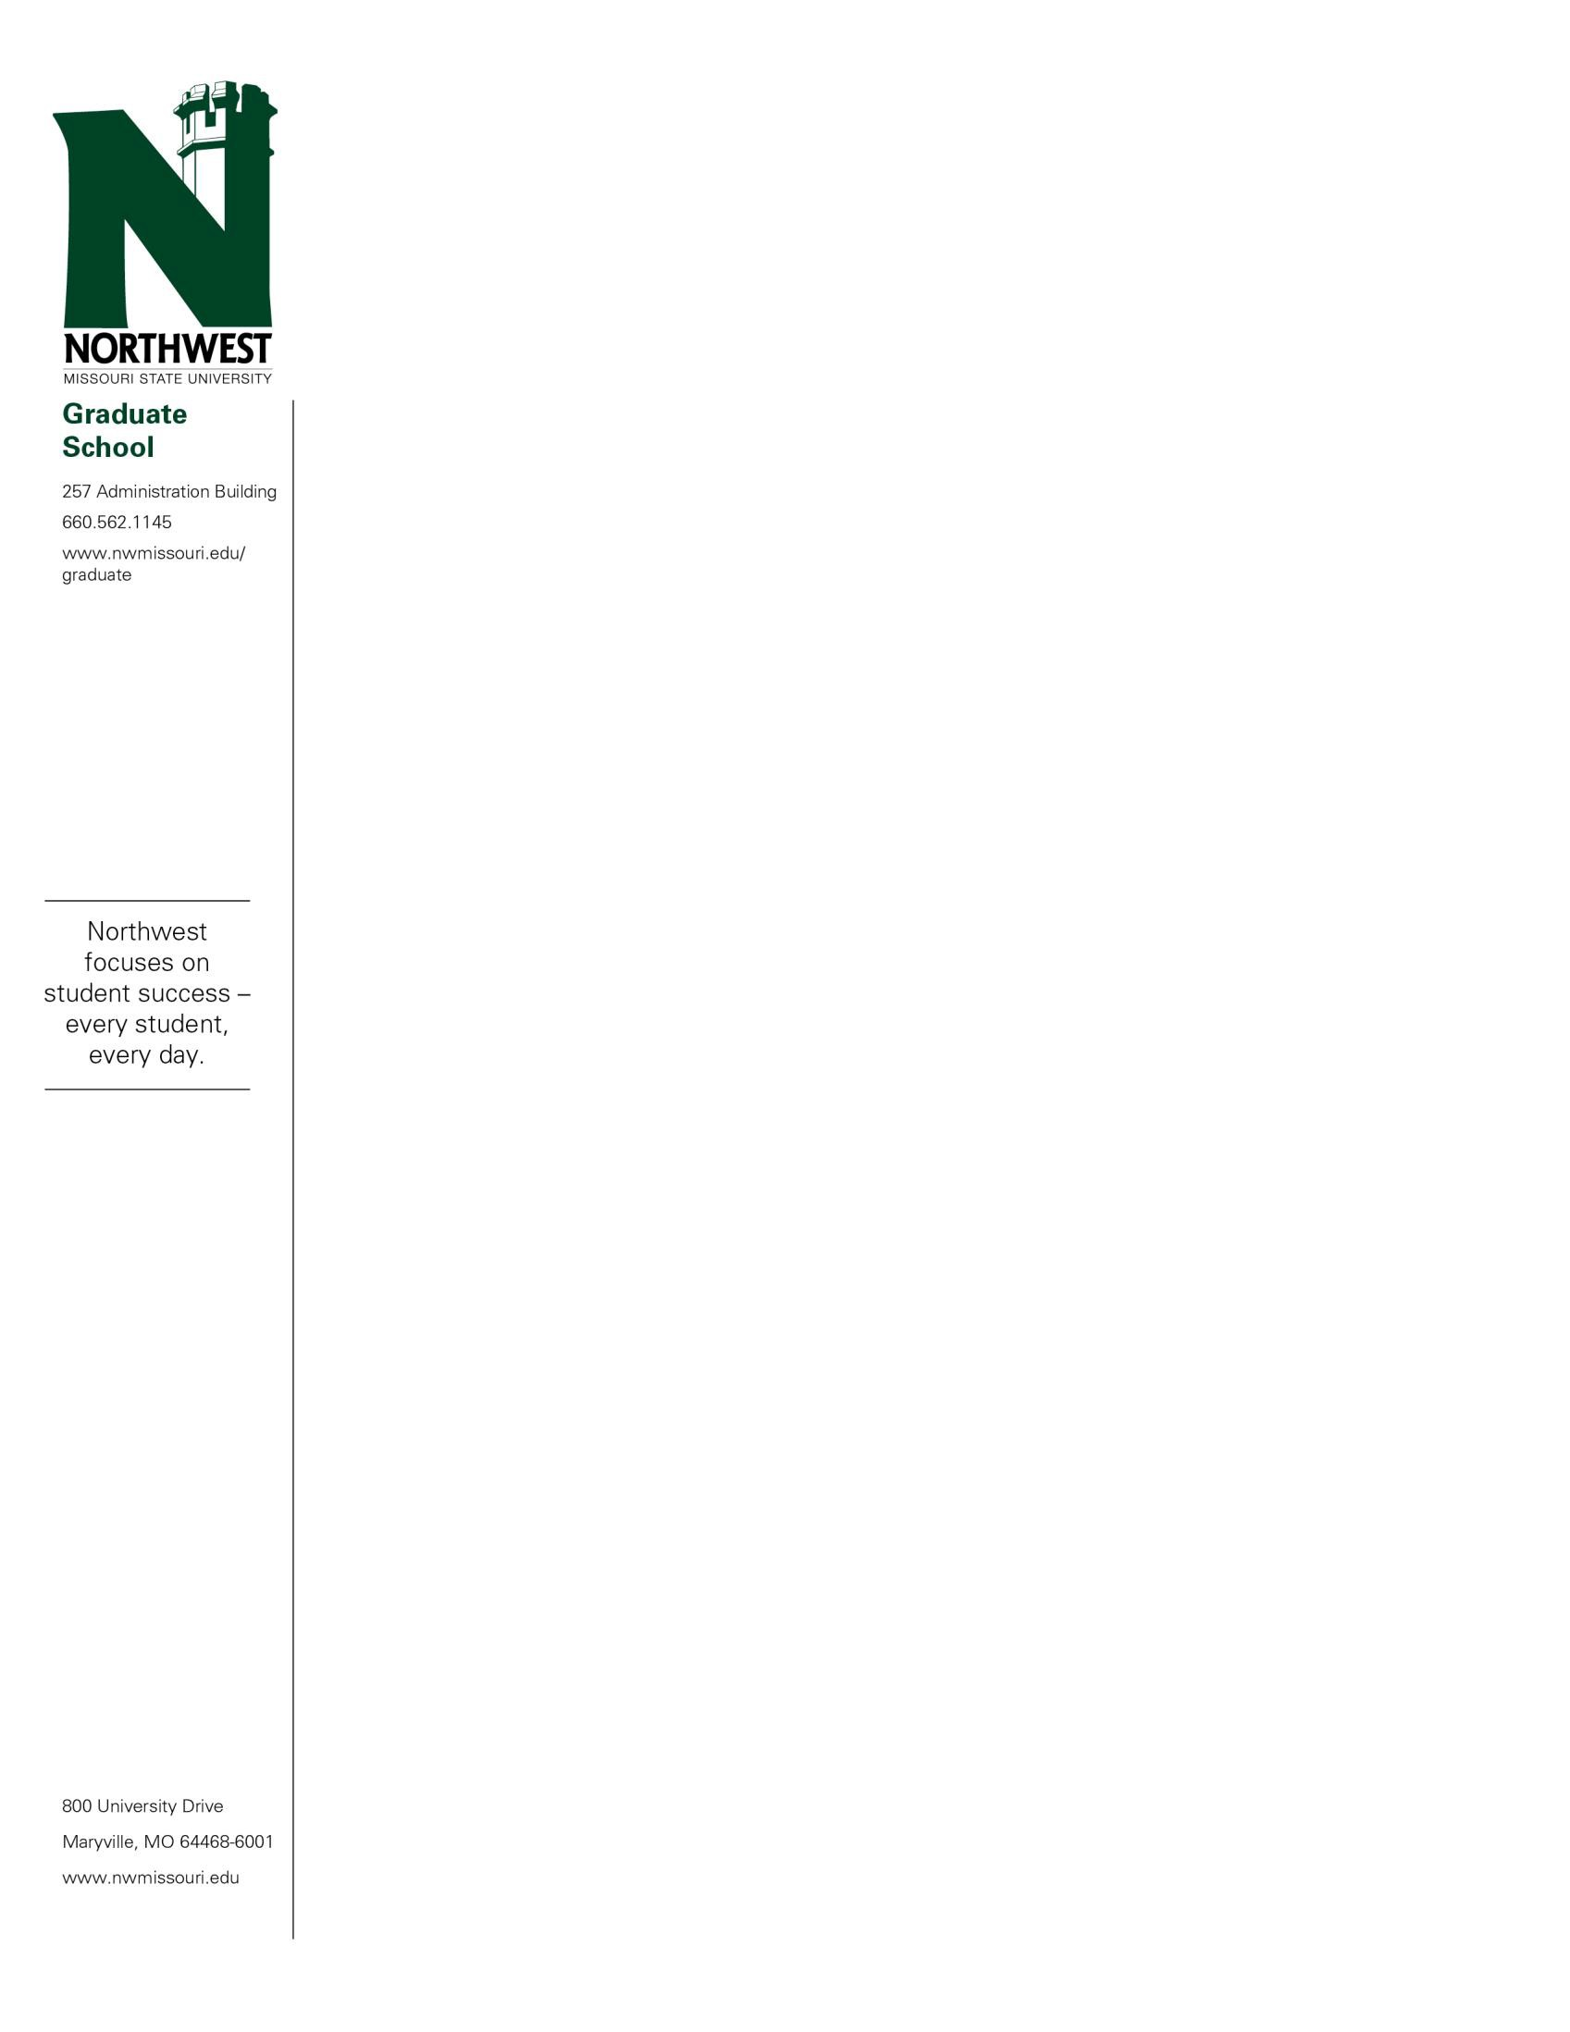

June 8, 2022

«FIRSTNAME» «LASTNAME»

«STREET»

«CITY», «STATE» «ZIP»

Dear «FIRSTNAME»:

Congratulations! You have been accepted into the Online Professional Specialist: Superintendency program beginning in the semester through Northwest Missouri State University.

The program director for your major is Dr. Kristina Alexander. You can reach Dr. Alexander for advisement at [KALEX@nwmissouri.edu](mailto:KALEX@nwmissouri.edu) or 660-562-1768.

Each state has different requirements for certification as a central leader.  There may be additional coursework not included in the program needed from various states to meet the certification requirements.  Some states require assessments on top of the completion of a degree program in educational leadership.  It is up to the student to research and engage in finding out the specific requirements for certification in the state in which they desire to become certified as a central level leader. States could have certain requirements such as teaching certificates, state assessments, building level certification, etc. At the conclusion of this program, students will have the coursework needed for certification application in the state of Missouri.  Please note, this only applies at the time of graduation.  If the state should change the requirements before the student applies for certification, additional requirements may be necessary. The following link provides more specific information regarding state specific licensure/certification for our education programs. <https://www.nwmissouri.edu/academics/stateauthorization-teaching.htm>

Please review this letter carefully and contact the Graduate Office at 660- 562-1144 with any questions or concerns.

All requirements submitted toward a Specialist degree must be completed within a period of eight years.

Northwest Missouri State University is proud of a long tradition of academic excellence, a fine faculty and a strong academic curriculum. We are happy for the opportunity to help you meet your educational goals.

Sincerely,

Gregory Haddock

Associate Provost of Graduate and Professional Studies